The Brigades British “Showcase” Marching Band & Soundsport Championships 2019
On behalf of everyone at The Showcase Committee thank you for your support and we hope you have an enjoyable day. If you require any assistance during the day please speak to one of our staff who will be happy to help. They will be in ‘Hi-Vis’ jackets. Your Showcase Co-Ordinator is Ray Westbrook and can be contacted on the day via the Emergency Number: “On the Day Only”: 07968 246532 Email: info@showcasemarchingbands.co.uk
Northwood - Indoor Arena​
The Brigades’ Showcase British Marching Band Championships this year will be held at Northwood Stadium. Keelings Road, Stoke-on-Trent, Staffordshire, ST1 6PA (In-Door Arena). Consequently will not be able to offer any official pre-performance warm-up or rehearsal time. Bands will however still have an opportunity to have a short warm up during the time allowed during your Maximum Performance Time.
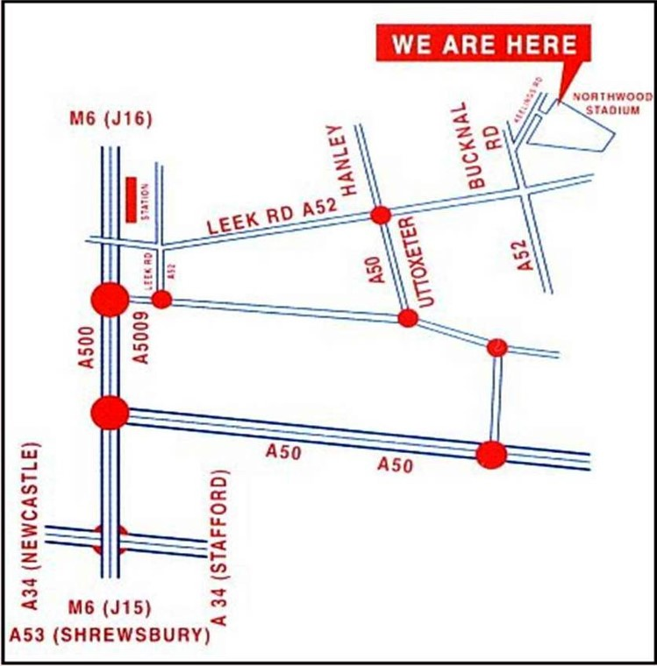

Bands on Arrival

Band vehicles should park as directed by the Marshals and the Bandmaster/Corps Director should go directly to the Band Reception by the Main Entrance. All Marching Members and Staff must remain with their vehicles until wristbands are issued. There will be STRICTLY NO ACCESS to the venue without a wristband. All Band and Staff wristbands will be issued in accordance with your Registration Forms. The Security Marshals will ask you to display your wristband at all times. Please check to ensure all Wristbands have been correctly fitted and you should always make sure your wristband is visible to the Security Marshals when entering through the Main Entrance, “Even when in Uniform” or you will be refused admission.
Return of Trophies
All Band Trophies from last year should be returned to the Band Reception Desk by the main entrance on your arrival.
Spectator Parking
On arrival all vehicles should park as directed by the Marshals. Since 2013 Stoke City Council have installed Pay & Display meters and all vehicles will be required to display a valid parking ticket.
Spectators Admission
Spectators will be able to purchase an Admission Wristband at the Main Reception Desk. Adults: £6:00. Children: £3:00. Concessionary: £4:00. All spectators must enter and leave the indoor arena via the Reception Desk by the Main Entrance Door.
Smoking Legislation
For the comfort of all spectators and our young people and to comply with legislation The Stadium and Indoor Venue, plus all of the surrounding grounds are regulated as: No Smoking Zones.
Indoor Seating is Limited
Please note the indoor arena has limited seating available and all spectators are asked to bring their own portable chairs. All spectator seating should be positioned below the balcony facing the display arena. No chairs will be allowed along the side walls either side of the display area, allowing bands to use the maximum width of the hall.
Toilets and Disabled Facilities

Toilet and disabled facilities are available via the Spectators Entrance (see Site Plan). Please remember to wear your “wristband” as proof of entry or you will be refused re-admission.
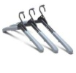 Changing Facilities

We are able to provide limited unsupervised changing facilities at Northwood Stadium’s Indoor Sports Hall and this will be and available only from 11:00 am until 5:00 pm. Once changed please do not leave any belongings unattended. Alternatively you are asked to change on your own vehicles.
Catering/Refreshments
A selection of Hot and Cold Refreshments will be available all day at reasonable prices: Hot Dogs, freshly made Sandwiches, Confectionery, Soft Drinks, Tea, and Coffee and will located behind the spectators area by the main entrance.
First Aid
The First Aid Post is situated in the Central Administration Area under the Main Balcony and will be signed posted accordingly and managed by a qualified First Aider.
Spectators - Safety​
For Health and Safety reasons be aware the Indoor Arena at times will be very busy and care should be taken to walk safely. PLEASE DO NOT RUN or obstruct the view or movement of our Judges, Officials and Film Camera Crew.
​ Litter
Litter Bins are provided please use them or take your rubbish home.
No Dogs
Please note the Venue is a "Sports Facility" consequently no dogs or animals are allowed anywhere on site or in the Stadium Grounds.

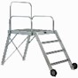 Indoor Arena – Layout
A Podium will be provided for Conductors/Drum Majors (usage at your own risk) or you can provide your own. The arena layout will be marked with cones with the 50 yard line being the official centre with cones/markers placed at intervals of 5 yards. i.e. 30, 35, 40, 45, 50. 45, 40, 35, 30, etc. the maximum width will be determined by the indoor hall measurements. The Pit Staging Area will be positioned immediately in front of the trophy table. All static equipment must be lifted or carefully wheeled and not dragged “in or out” of the Performance Arena.
Judges Audio Recordings & Collection Times
All of our Judges spoken comments will be provided on a USB memory stick as both a Windows Media (.WMA) file and an MP3 file format (.MP3). You can also supply up to a maximum of (TWO) of your own USB stick or MP3 Players for additional copies. These must be presented to the Band Reception Desk on your arrival and CLEARLY MARKED with your Band’s name. Every effort will be made to copy the files on to your supplied devices but please ensure that any specialised cables/software are also provided and your MP3 player supports WMA playback. The Judges recorded comments will be available approximately 20 minutes after the conclusion of your performance and should be collected from the Band Reception Desk by your ‘Official Representative’. If you plan to attend the Judges Critique it is recommended that you first listen to their comments to formulate your questions and comments and to make the experience as constructive as possible.
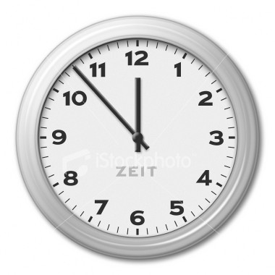 Band Performance - Report Time
All participating bands are required to report to the Band Controller Marshall at the “Band Control Area” located by the back door of the indoor arena on the east side of the building. Please report to the Band Controller ten minutes prior to your performance time as indicated on the timetable. Failure to report at the correct time may result in penalty points being incurred, if in the opinion of the Showcase Referee an advantage has been obtained over other competing units. If any alterations to the timetable are necessary these will be notified to you as soon as possible. All bands when entering the In-door arena must do so in silence as other bands will be performing. Any unit or part thereof found playing in the vicinity of the outside venue after the official start time of the Championships risks disqualification. Please note only participating members and staff wearing the correct wrist band will be allowed to enter via the Band Control Area. Each Band/Corps will be under the sole control of the Drum Major, Lead Musician or Officer in Charge from entry into the marshalling area until clearing the Arena at the completion of their performance. They in turn will take their instructions from the Band Controllers. Each Band/Corps, according to “Class” is allocated a Maximum Time” and “Minimum Display Time”. Please see Showcase Rules for the precise timings.

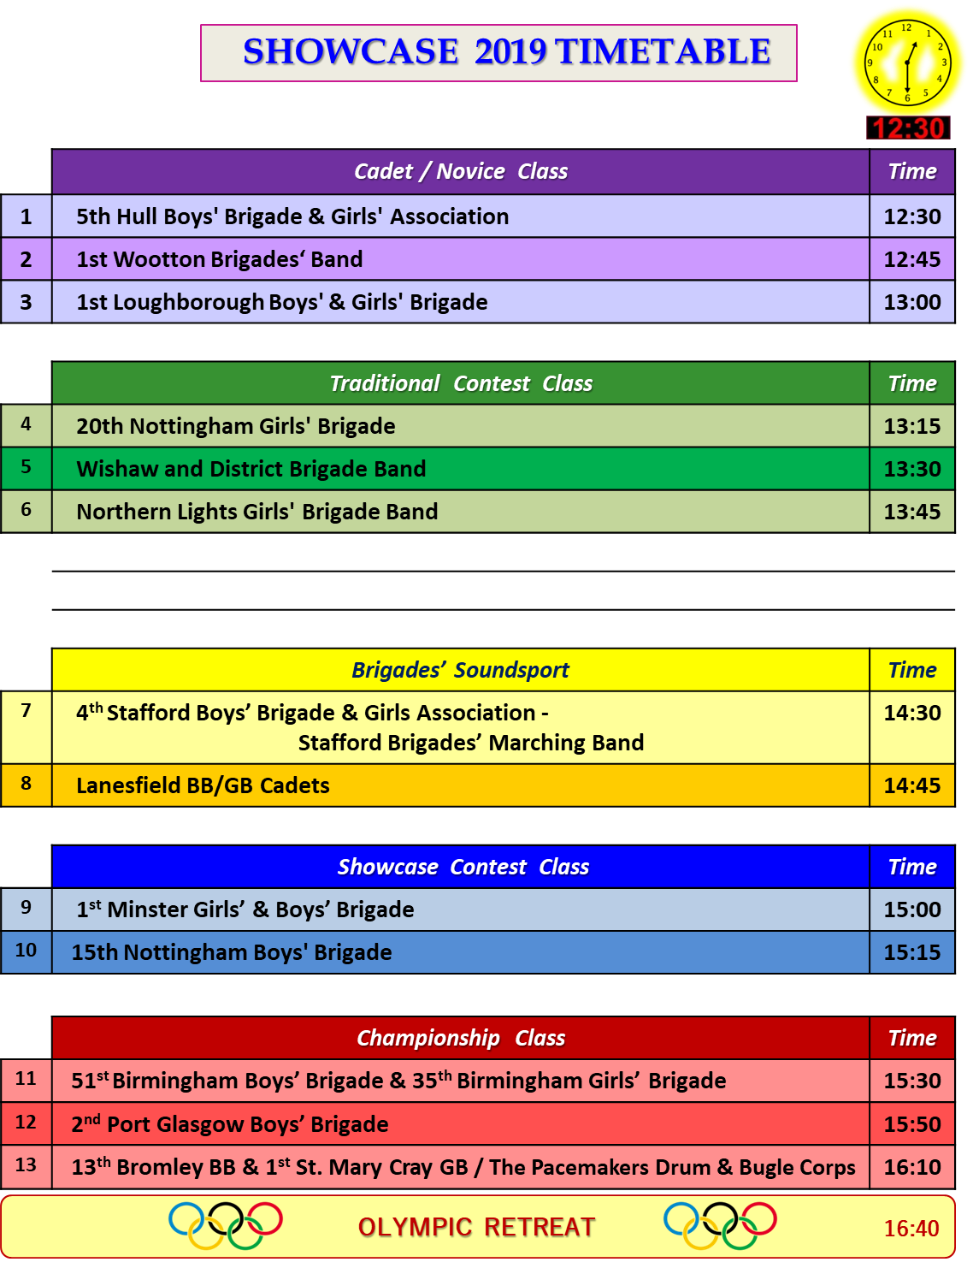
- INTERVAL -
On Leaving the Indoor Arena
All band members and pit equipment will exit (stage left) via the side exit, on either a single drum beat or drum rhythm, which must stop when all marching members have left the arena. All pit equipment and scenery must be returned to your transportation vehicles after your performance.
Olympic Retreat (Please listen for announcements as timings may vary)
At the conclusion of the Showcase Championships all competing Bands/Corps will be asked to participate in the “Olympic Retreat” and “Awards Presentation”. Bands will be required to form a single line in “Performance Order” outside of the Band Control Entrance at the end of the Championships. Please follow the Marshall’s instructions. Spectators must not go onto the Arena during the Olympic Retreat.

Critique - Timetable
Those bands who have indicated they wish to attend the Critique have been allocated the following times: (Please listen for announcements for possible time changes)

Please also remember to bring you Judges “Remark Sheets” with you, as this helps our Judges recall their comments whilst discussing your Band’s performance.

Please do not be late for your critique as you may lose your allocated time:

2nd Port Glasgow Boys' Brigade | 17:15 Hrs
Wishaw and District Brigade Band | 17:15 Hrs
Northern Lights Girls’ Brigade | 17:23 hrs
1st Wootton Boys' & Girls' Brigade | 17:23 hrs
1st Loughborough Boys' & Girls' Brigade | 17:31 hrs
Lanesfield BB / GB Cadets | 17:31 hrs
51st Birmingham Boys' Brigade & 35th Birmingham Girls' Brigade | 17:39 hrs
13th Bromley Boys' Brigade & 1st ST. Mary Cray Girls' Brigade | 17:39 Hrs

The Judges Critique will commence as soon as possible, after the results have been announced and held in the Showcase Office/Officials Room below the main balcony. The order in which bands enter Critique is be based on those travelling the furthest, consequently those having to travel the longest distance will be scheduled first. Two bands will enter Critique at once. One with the General Music Effect, Visual Display and Drill & Deportment/Field Visual Judges and the Second Band’s Instructors with the Field Wind and Field Percussion Judges. After 4 minutes the Bands’ staff will swap captions giving a total Critique time of 8 minutes to each band. The next two bands will then enter Critique and the same scenario will commence, swapping between captions every 4 minutes until all bands have been seen. No more than 2 staff per Judge please! There are five Judges in total. It is feasible that an instructor will want to only visit one caption Judge and so they should wait until their band moves to the appropriate caption, unless that specific Judge is available earlier. Please remember Critique is a time to discuss and make positive comments and to ensure you make the best use of our Judges knowledge in their particular field of expertise, plus making the experience as constructive as possible.
​ 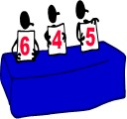 Caption - Showcase Scoring System
There will be a maximum of five Judges and they are each allocated a total of 200 points using a box scoring system. The caption scores awarded are then divided by 10 to give a total score out of 100 marks. The full criteria and definitions can be found in the Showcase Rules and points are awarded in the following categories:
(1) General Music Effect: Richard Coulter. (2) General Visual Effect: Richard Haw. (3) Field Visual: Andrew Horton. (4) Field Wind: Tony Hendle. (5) Field Percussion: Kevin Gannaway-Pitts.
Soundsport: (1) Music: Richard Coulter. (2) Visual: Richard Haw. (3) Overall Impression: Andrew Horton. For Soundsport there are NO Caption Scores. All participating units will be awarded a Bronze, Silver or Gold award according to merit.​​ ​
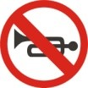 No ‘after contest’ performances
Due to the Stadium and Local Council Regulations, no additional performances or playing of instruments will be allowed after the conclusion of the “Showcase Event”. Each band will be invited to play as they leave the Showcase Arena, following the Results and Presentations Ceremony.
Rehearsal / Warm up / Tune up Area
​Bands are encouraged to arrive during the morning prior to the “Showcase” start time and rehearsals will be permitted on specified areas around the Stadium on a first come first served basis between 09:45 am and 12:00 noon. Please check at the Band Reception desk first and availability will but subject to the current weather conditions on the day. Any unit or part thereof found playing in the vicinity of the indoor venue after the official start time risks disqualification.​​
Video Recordings & Photography
​Personal Video Recordings and Photography are permitted but please remember not to obstruct our Judges, our official photographer and other spectators.
Programme
A Souvenir Programme can be purchased for £1:00

